Visvesvaraya Technological University

BelAgaVI-590 018


Internship / Professional Practice Report
on

“Finding the stage of cancer as malignant or benign using Logistic Regression”

Submitted in partial fulfillment of the requirements for the Final year degree of Bachelor of Engineering in Computer Science and Engineering
of Visvesvaraya Technological University, Belagavi

by

Varsha Ravindra 1RN15CS119

Carried out at
TechieAid

Under the Guidance of:

Internal Guide: External Guide (TechieAid)
Dr. Shashidhara H R Mr. Jagadeesh
Associate Professor Guide for machine learning
Dept. of CSE TechieAid
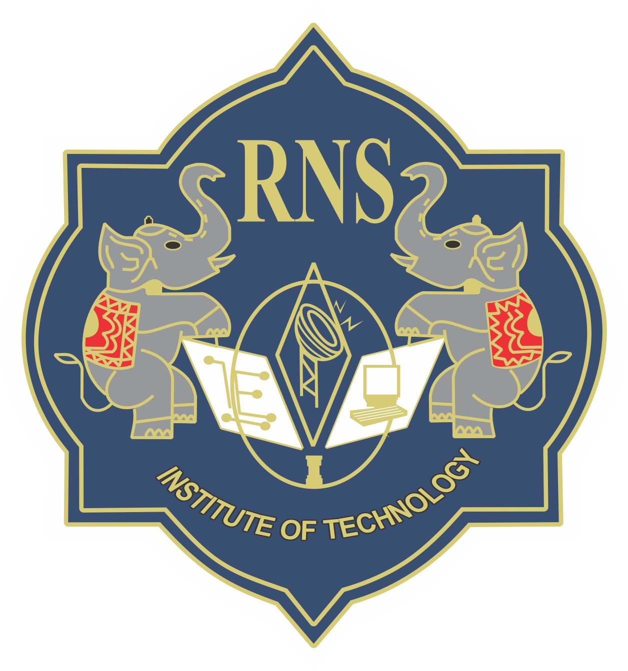

Department of Computer Science and Engineering
R N S Institute of Technology
Channasandra, Dr.Vishnuvardan Road, Bengaluru-560 098
2018-2019

R N S Institute of Technology
Channasandra, Dr.Vishnuvardan Road, Bengaluru-560 098

Department of Computer Science & Engineering

Internship CERTIFICATE
Certified that the Internship/ Professional Practice work entitled “Finding the stage of cancer as malignant or benign using Logistic Regression” has been successfully carried out at “TechieAid”, by Varsha Ravindra bearing 1RN15CS119, bonafide student of RNS Institute of Technology in partial fulfillment of the requirements for the Final year degree in Bachelor of Engineering in Computer Science and Engineering of Visvesvaraya Technological University, Belagavi during academic year 2018-2019. It is certified that all corrections/suggestions indicated for Internal Assessment have been incorporated in the report deposited in the departmental library. The Internship report has been approved as it satisfies the academic requirements in respect of Internship work for the said degree.

Dr. Shashidhara H R Dr. G T Raju Dr. M K Venkatesha
Associate Professor Vice -Principal Principal
Professor, HoD-CSE

External Viva:
Name of the Examiners Signature with Date
1.
2.

ACKNOWLEDGMENT
At the very onset, I would like to place on record our gratefulness to all those people who have helped us in making this internship work a reality. Coming up with this Internship work to be a success was not easy. Our Institution has played a paramount role in guiding us in the right direction.
I would like to profoundly thank the Management of RNS Institute of Technology for providing such a healthy environment for the successful completion of this Internship / Professional Practice work.
I would like to express my sincere thanks to our respected Director, Dr. H N Shivashankar for his constant encouragement that motivated me for the successful completion of this work.

I would also like to thank our beloved Principal, Dr. M K Venkatesha, for providing the necessary facilities to carry out this work.

I am extremely grateful to our beloved Vice–Principal and HoD-CSE, Dr. G T Raju, for having accepted to patronize me in the right direction with all his wisdom.

I place my heartfelt thanks to all the Coordinators- Internship / Professional Practice. I would like to thank the internal guide Dr. Shashidhara H R, Assoc. Professor, for his continuous guidance and constructive suggestions for this work.
It’s my pleasure to thank TechieAid for providing me the best platform to complete the internship work and glad to thank the extremal guide Mr. Jagadeesh, for corporate exposure, training and guidance.

Last but not the least, I am thankful to all the staff members of Computer Science and Engineering Department for their encouragement and support throughout this work.

Varsha Ravindra
1RN15CS119

